



Incident Response Platform Integrations

Machine Learning Function V1.1.1
Release Date: July 2020

Resilient Functions simplify development of integrations by wrapping each activity into an individual workflow component. These components can be easily installed, then used and combined in Resilient workflows. The Resilient platform sends data to the function component that performs an activity then returns the results to the workflow. The results can be acted upon by scripts, rules, and workflow decision points to dynamically orchestrate the security incident response activities.
This guide describes the Machine Learning Function.

Overview
Resilient Machine Learning function provides a tool kit for users to train models using historical incident data. The models can then be used to make prediction for new incidents. This tool is integrated with Resilient platform and customized for Resilient users.
This integration provides the followings:
- A command line tool to build machine learning models
- A predict function that predicts a given field of an incident
Together with the above, this package also includes an example workflow that demonstrates how to call the function above, a rule that starts the workflow, and a custom field the function uses to write the prediction.

History
Resilient Incident Response Platform Machine Learning Function Reference Guide
Platform Version | Publication | Notes
1.1.1 | July 2020 | Include pandas .whl file in source code.
1.1.0 | March 2020 | New ml.config file is used to build, train, and test machine learning models.
1.0.0 | December 2018 | Initial publication.

Installation
Before installing, verify that your environment meets the following prerequisites:
- Resilient platform is version 30 or later.
- You have a Resilient account to use for the integrations. This can be any account that has the permission to view and modify administrator and customization settings, and read and update incidents. You need to know the account username and password.
- You have access to the command line of the Resilient appliance, which hosts the Resilient platform; or to a separate integration server where you will deploy and run the functions code. If using a separate integration server, you must install Python version 2.7.10 or later, or version 3.6 or later, and “pip”. (The Resilient appliance is preconfigured with a suitable version of Python.)

Install the Python components
The functions package contains Python components that are called by the Resilient platform to execute the functions during your workflows. These components run in the Resilient Circuits integration framework.
The package also includes Resilient customizations that will be imported into the platform later.
Complete the following steps to install the Python components:
- Ensure that the environment is up-to-date, as follows:
sudo pip install --upgrade pip
sudo pip install --upgrade setuptools
sudo pip install --upgrade resilient-circuits
- Run the following command to install pandas:
sudo pip install pandas-0.23.4-cp27-cp27m-linux_x86_64.whl
This step is necessary because there is no wheel for pandas on Redhat Enterprise 7 available from pip. Also Redhat Enterprise 7 does not have gcc/g++ installed, so pip cannot build it from source code. A wheel was built locally, using the source code of https://files.pythonhosted.org/packages/e9/ad/5e92ba493eff96055a23b0a1323a9a803af71ec859ae3243ced86fcbd0a4/pandas-0.23.4.tar.gz. This is the same source code as the “pip install pandas” downloads. This file can be found under the dependencies/ folder in the source code.
- To install the package, you must first unzip it then install the package as follows:
sudo pip install --upgrade fn_machine_learning-<version>.<tar.gz>

Configure the Python components
The Resilient Circuits components run as an unprivileged user, typically named integration. If you do not already have an integration user configured on your appliance, create it now.
Complete the following steps to configure and run the integration:
- Using sudo, switch to the integration user, as follows:
sudo su - integration
- Use one of the following commands to create or update the resilient-circuits configuration file. Use –c for new environments or –u for existing environments.
resilient-circuits config -c
or
resilient-circuits config -u
- Edit the resilient-circuits configuration file, app.config, as follows:
  - In the [resilient] section, ensure that you provide all the information required to connect to the Resilient platform.
  - In the [machine_learning_predict] section, edit the settings as follows:
model_dir=path to the folder you are going to save your model files
- Create the directory where the model files will be saved. The path to this directory will be used for model_dir in app.config.
- From the directory specified by model_dir, use the res-ml command line tool to create two files: ml.config and res-ml.log
res-ml config
- Edit the ml.config file, edit the [machine_learning] section:
﻿#
# Field to predict
#
prediction=severity_code
#
# Features to use
# example:features=confirmed, incident_type_ids, negative_pr_likely
features=list_of_fields_for_features_separated_by_comma
#
# Algorithms supported:
# Logistic Regression, Decision Tree, Random Forest,
# Dummy Classifier, SVM, SVM with Gaussian kernel, GaussianNB,
# BernoulliNB, K-Nearest Neighbors
algorithm=Logistic Regression
#
# Ensemble method is optional, it can be Bagging or
# Adaptive Boosting (Optional)
#
method=None
#
# Split samples for testing. 0.5 means 50% of the samples will be
# used for testing
#
split=0.5

#
# Advanced options
#-----------------
#
# 1. Imbalance Class
#
# Predicted data could be imbalanced. Uncomment one of the following
# option to handle it
#
class_weight=balanced
#imbalance_upsampling=true
#
# 2. Data Preparation
#
# Some prediction values could be misleading for the machine
# learning model Put those values below. Samples with those
# values will be removed
#
unwanted_values=None
#
# 3. Filter (Optional)
#
# * Time filter: format YYYY-mm-dd
#
#time_start=2018-10-01
#time_end=2018-10-08
#
# * Count: Maximum number of samples to process
#
#max_count = 10000

Deploy customizations to the Resilient platform
This package contains one function definitions and includes one example workflow and a rule that runs this function.
- Use the following command to deploy these customizations to the Resilient platform:
resilient-circuits customize
- Respond to the prompts to deploy functions, message destinations, workflows and rules.

Run the integration framework
To test the integration package before running it in a production environment, you must run the integration manually with the following command:
resilient-circuits run
The resilient-circuits command starts, loads its components, and continues to run until interrupted. If it stops immediately with an error message, check your configuration values and retry.

Configure Resilient Circuits for restart
For normal operation, Resilient Circuits must run continuously. The recommend way to do this is to configure it to automatically run at startup. On a Red Hat appliance, this is done using a systemd unit file such as the one below. You may need to change the paths to your working directory and app.config.
- The unit file must be named resilient_circuits.service To create the file, enter the following command:
sudo vi /etc/systemd/system/resilient_circuits.service
- Add the following contents to the file and change as necessary:
[Unit]
Description=Resilient-Circuits Service
After=resilient.service
Requires=resilient.service
[Service]
Type=simple
User=integration
WorkingDirectory=/home/integration
ExecStart=/usr/local/bin/resilient-circuits run
Restart=always
TimeoutSec=10
Environment=APP_CONFIG_FILE=/home/integration/.resilient/app.config
Environment=APP_LOCK_FILE=/home/integration/.resilient/resilient_circuits.lock
[Install]
WantedBy=multi-user.target
- Ensure that the service unit file is correctly permissioned, as follows:
sudo chmod 664 /etc/systemd/system/resilient_circuits.service
- Use the systemctl command to manually start, stop, restart and return status on the service:
sudo systemctl resilient_circuits [start|stop|restart|status]
You can view log files for systemd and the resilient-circuits service using the journalctl command, as follows:
sudo journalctl -u resilient_circuits --since "2 hours ago"

Function Descriptions
This integration package contains two components.
- A command line component to build machine models.
- A function component to predict using a saved machine model.
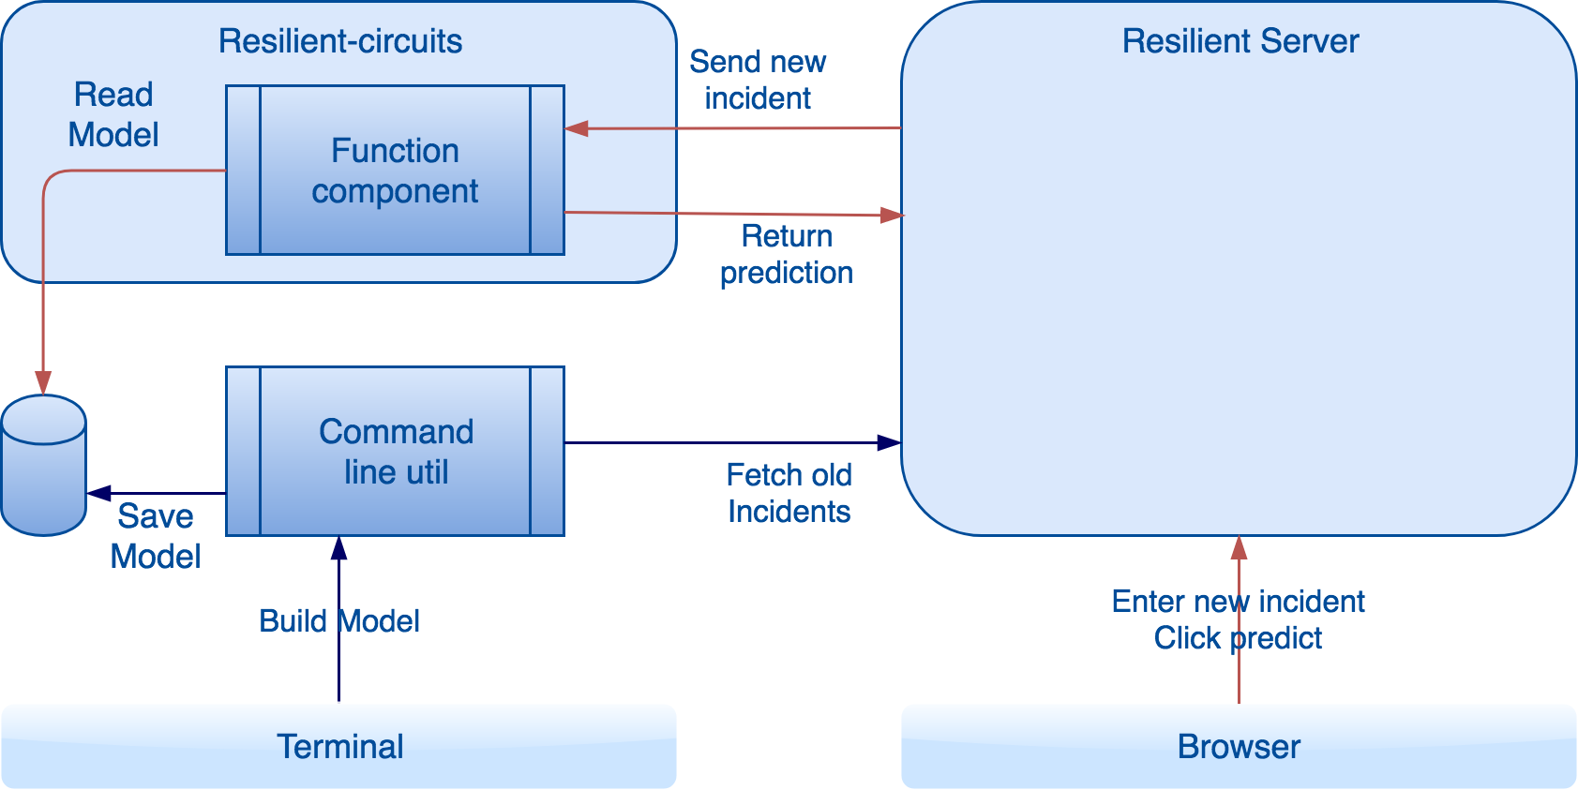
As shown in the above graph, users use the command line tool from a terminal to build a machine learning model. The command line tool reads configuration settings from the app.config file, and connects to the specified Resilient server to fetch incidents. These incidents are the samples used to train a machine model. The app.config file also contains other settings about the model to build, such as the features, the field to predict and algorithm. The command line tool can then build the model and saves it into a file.
The function component takes an incident ID and a file name. It retrieves the incident using the ID, and loads the saved model using the file name. It can then use the model to make predictions for this incident. This is triggered by a menu item in the incident page.
In summary, there are two processes, one to build a machine learning model, the other to make predictions using a model.

Build a Machine Learning Model
The command line tool is used to build machine models. It contains 5 subcommands.

Download
This subcommand is used to download incidents from a Resilient platform, and then save them into a CSV file. The Resilient platform is specified in the ml.config file. The subcommand has the following parameter:
-o | Required. File path to the file to save the CSV file
Example:
res-ml download -o resilient_incidents.csv
Example output:
It shows in this example that 5 incidents have been downloaded and saved into resilient_incidents.csv.

Build
This subcommand is used to build a new model. The command line tool reads settings from ml.config regarding the features, predict, and algorithm. The default settings in ml.config shall be valid for a basic model. Users shall adjust them to get better performance.
This subcommand takes two flags:
-o | Required. File path to the file to save the built model
-c | Optional. File path to a CSV file that contains the samples.  If this flag is absent, the tool downloads incidents from the Resilient Server (specified in app.config) as samples. If this flag is given, the CSV file is used for samples.
Example:
res-ml build -c resilient_incidents.csv -o first_model.ml
If the model can be built successfully, you see a summary; for example:
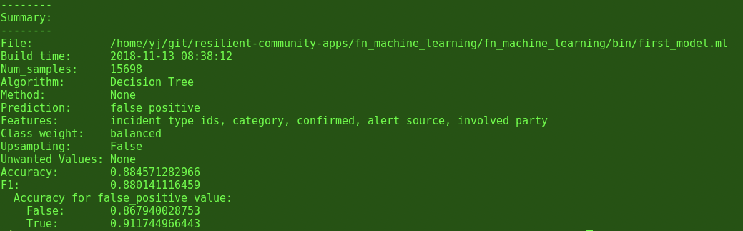
It shows the overall accuracy, and the accuracy for each value of the predicted field. Here the predicted field (false_positive) has two values: False and True. The accuracy for True is 91.17% and the accuracy for False is 86.79%. The overall accuracy is 88.45%. Please refer to Resilient Machine Learning Reference Guide for more details regarding the other fields.
In this example, the model is built and saved into a file called first_model.ml.

View
This subcommand is used to view a saved model. When more than one models are built for comparison, this subcommand is useful to figure out which model to use.
It takes one flag:
-i | Required. File path to the saved model to be rebuilt
Example:
res-ml view -i first_model.ml
It shows the summary of the saved model. The output is the same as the build subcommand.

Rebuild
This subcommand is used to rebuild a saved model. After a model is built and used for a while, new incidents are accumulated. A model needs to be updated and this subcommand is for rebuilding the model. It takes two flags:
-i | Required. File path to the saved model to be rebuilt
-c | Optional. File path to a CSV file that contains the samples.  If this flag is absent, the tool downloads incidents from the Resilient Server (specified in ml.config) as samples. If this flag is given, the CSV file is used for samples.
Please note that when a model is rebuilt, the predict/features/algorithm/method information are taken from the saved file instead of from ml.config. This subcommand is intended for rebuilding/updating a successful model after new samples are available.
Example:
res-ml build -i lg_adaboost.ml
If the model can be rebuilt successfully, a summary is shown.

Count-value
This subcommand is used to detect imbalanced dataset. Please refer to Resilient Machine Learning Reference Guide for details about imbalanced dataset and the recommendations to optimize the performance of a model for handling it.
-i | Required. File path to the CSV file that contains the models
-f | Required. The field you want to check value count.
Example:
res-ml count_value -i resilient_incidents.csv -f false_positive
The output shows the count of each value of this field “false_positive”.

In this example, there are three values. “None” means some incidents have this “false_positive” empty.

Use a model to predict
Once a machine model is built and saved, it can be used to make prediction by the function component. The function component locates the saved model to use by looking at the following:
- Model folder: “model_folder” is set in app.config. A saved model file needs to be in this folder.
- Model name: The name of the model to be used is given as an input to the function. It can be set in the input tab of the workflow that calls the function. For the sample workflow included in this package, the default name is “incident_predition.ml”. If you are using the sample workflow to make prediction, you need to copy the model file you want to use into the model folder as incident_predition.ml.
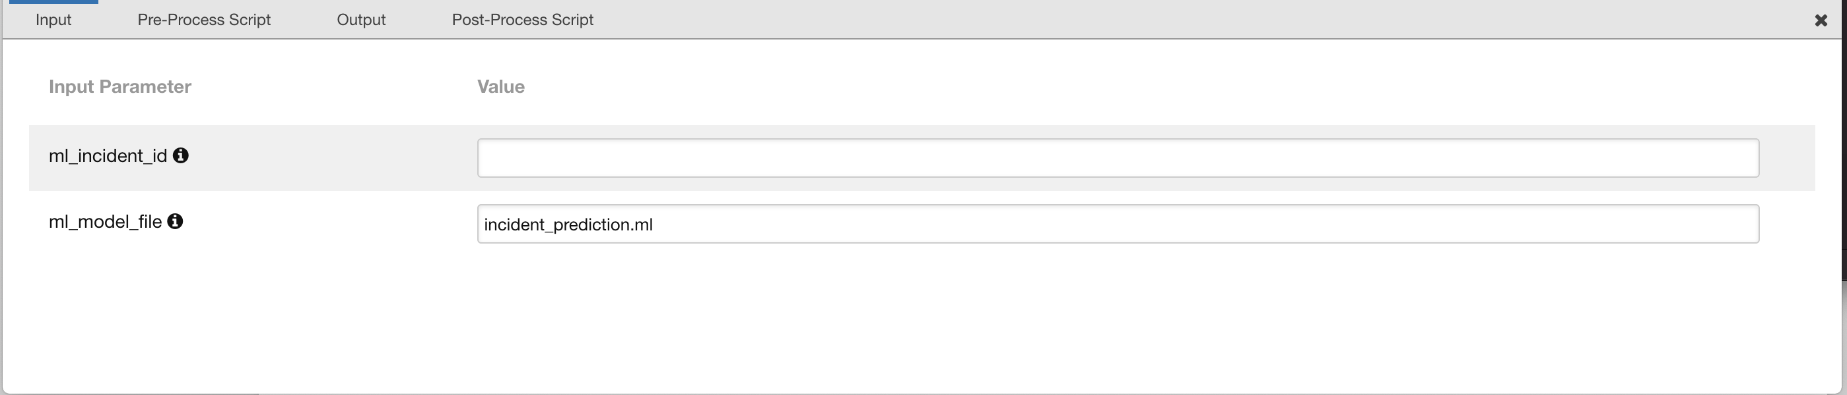
The sample workflow writes the prediction into a custom field call ml_prediction. To show this in the incident page, add this customer field to it. You can go to Customization Settings page and create a new tab call “Machine Learning”. Then add this custom field into the newly created tab.
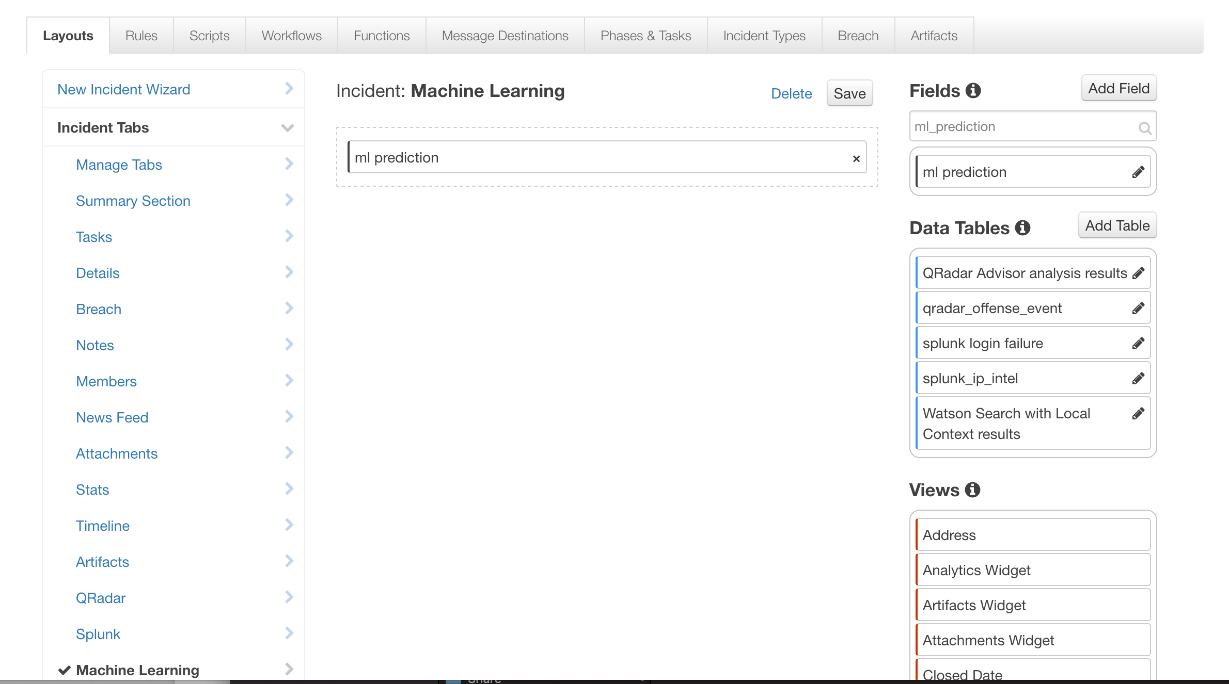
Then this new tab and the custom field is shown in the incident page.
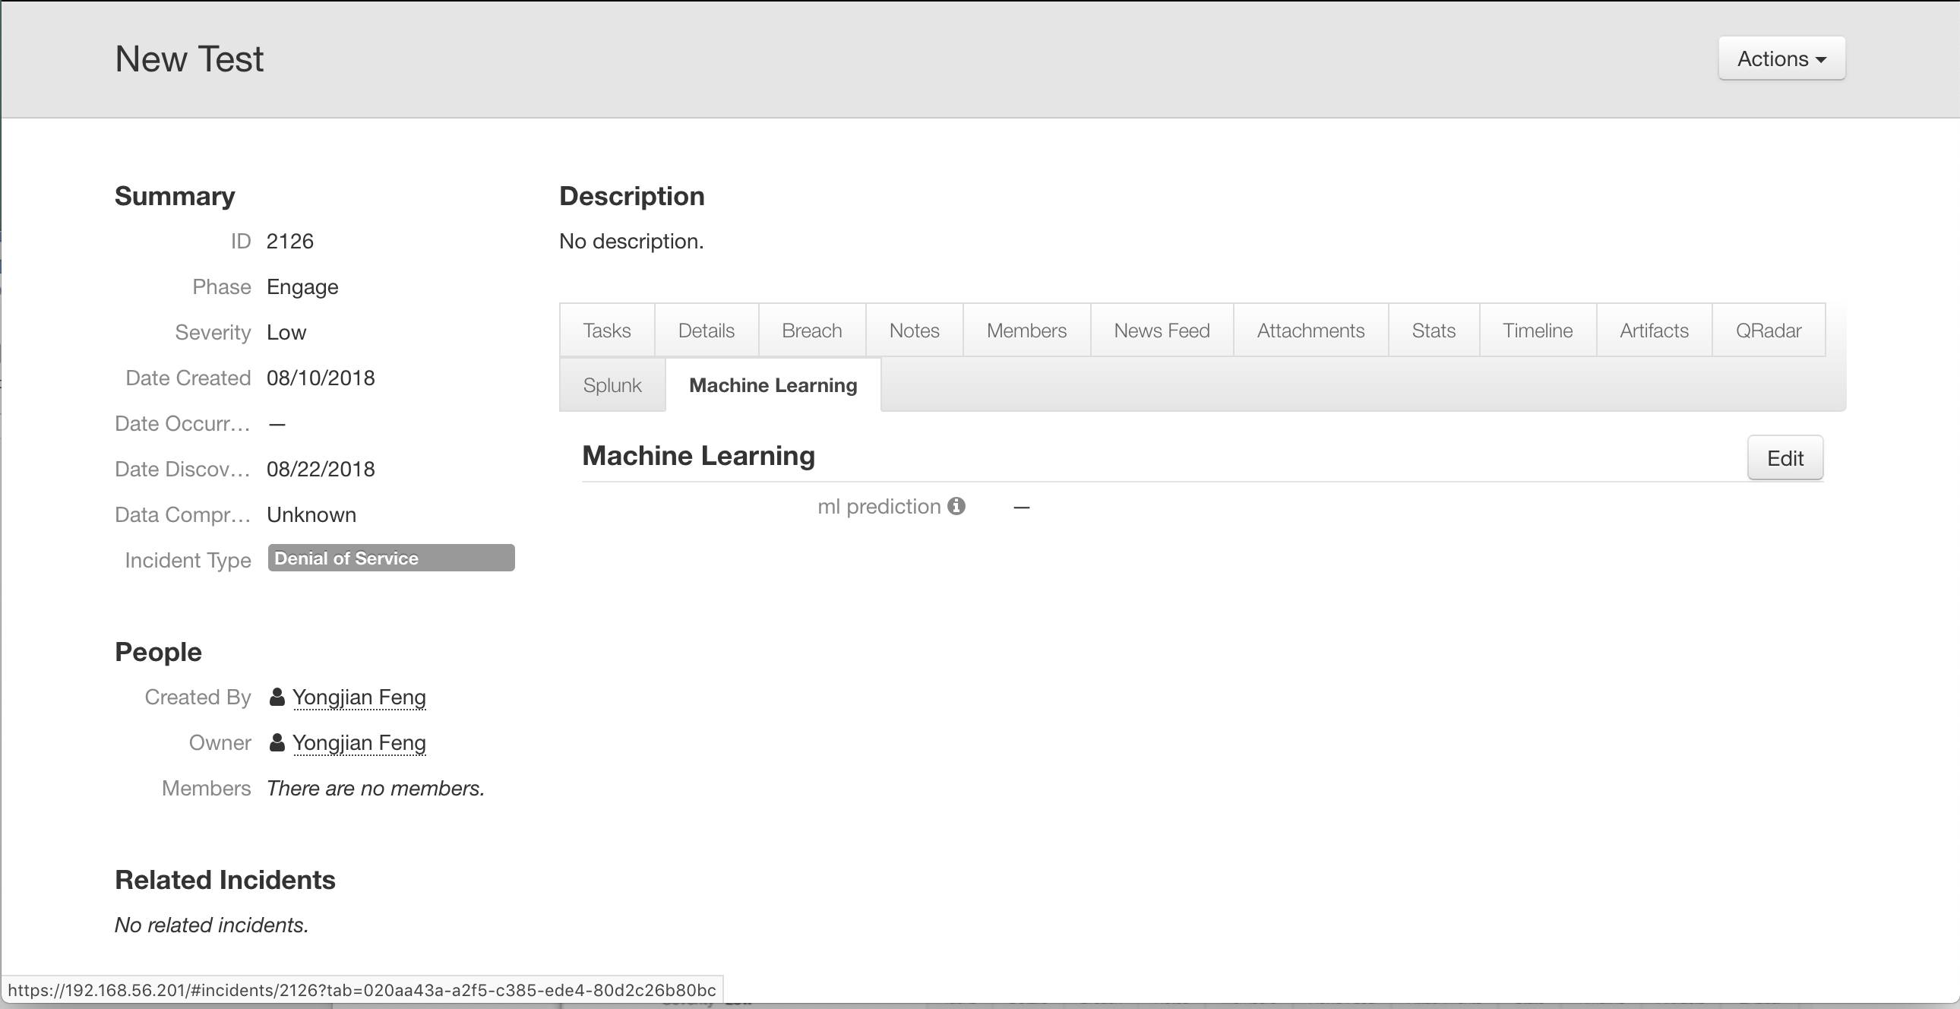
Now we are ready to make a prediction. Please note that you need to ensure that all the features are non-empty. Go to the “Details” tab to check. For the default settings, features are “NIST Attack Vectors”, “Incident Type”, “Incident Disposition”, and “Negative PR”. As shown in the following screenshot, none of these fields are blank. This an incident that the function can predict.
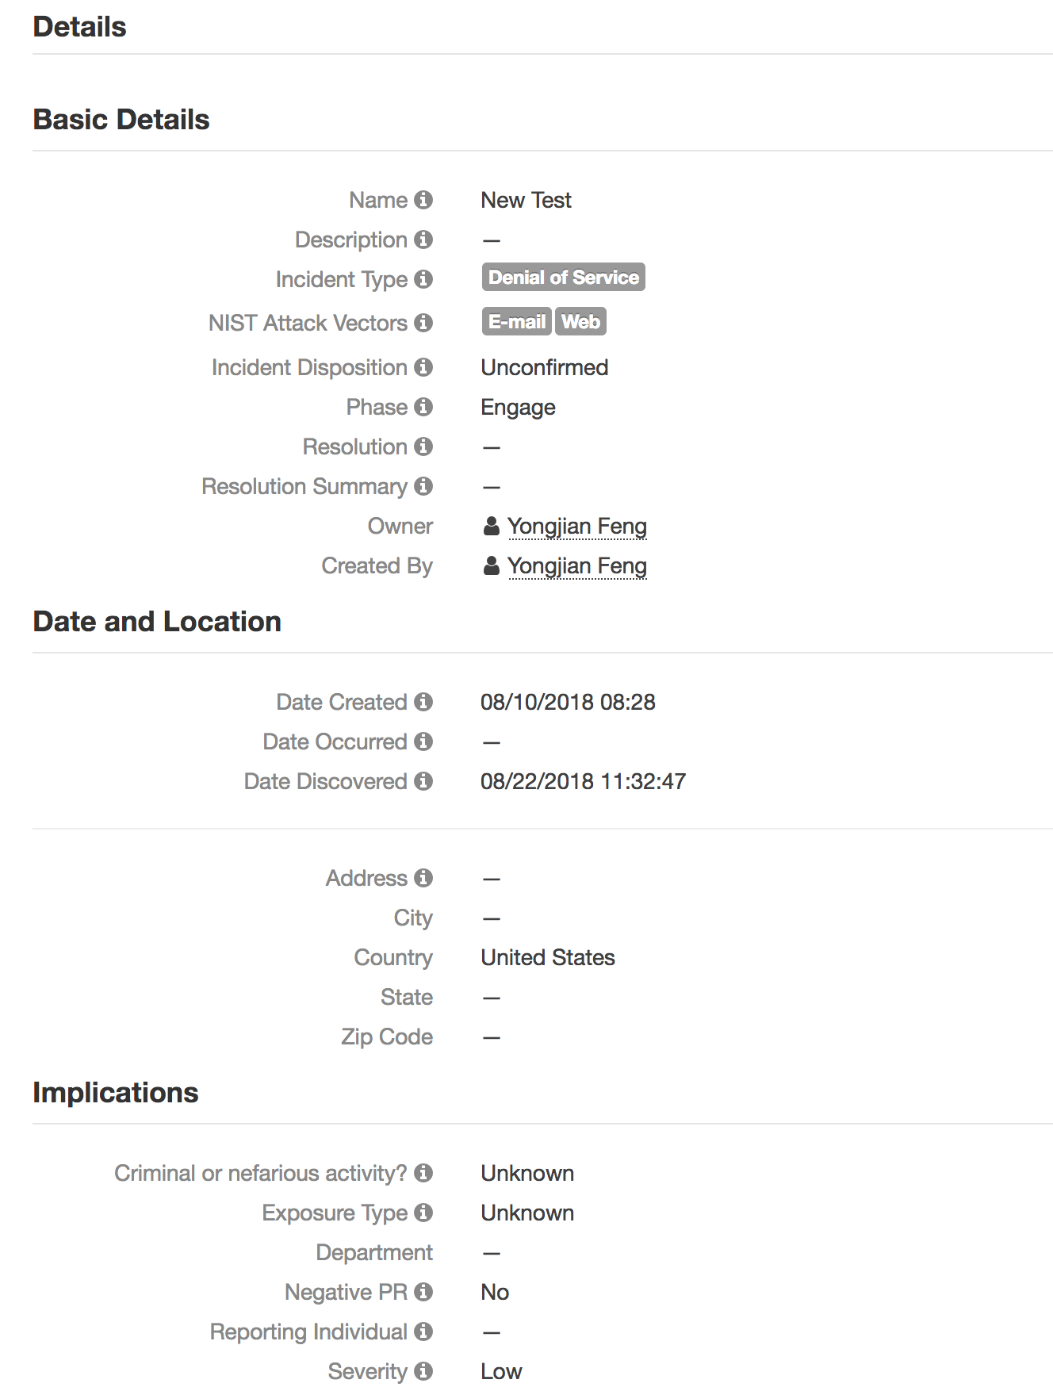

From the incident Actions, select “ML Predict”.
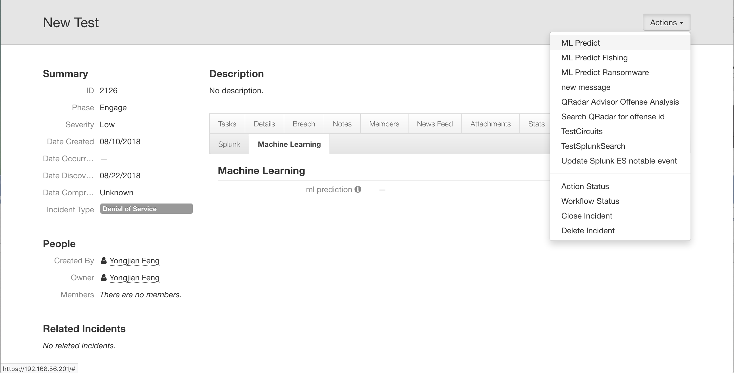
Wait for the integration to finish its job. The prediction is shown.

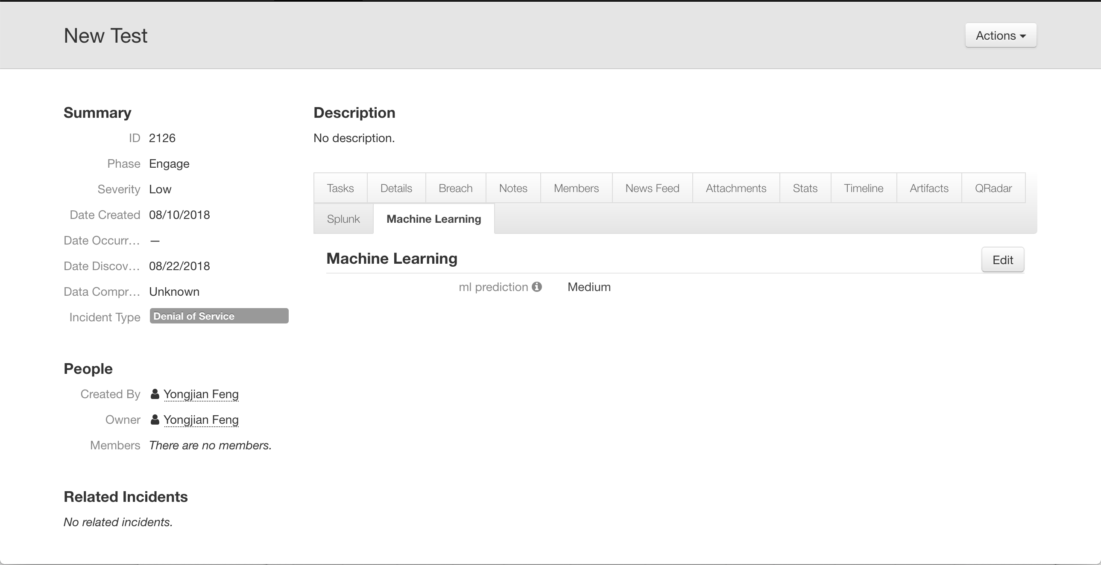

Build multiple models
When res-ml is executed, it looks for ml.config using this order:
- ml.config file in the same folder where res-ml runs.
- app.config in the .resilient folder of the home directory.
If a user wants to maintain multiple models, one way to do it is to keep each model in its own folder with its own ml.config.

Use multiple models to predict
If a user wants to predict more than one field, then multiple models are needed. For example, a user can use one model to predict “severity_code”, and another model to predict “owner”. The multiple models need to be built first. Also, multiple workflows are needed, one for each model. All workflows call the same function but provide different input regarding the model file to use.
Most likely, a user also needs to create multiple rules, one for each workflow.

Resilient Platform Configuration
There are two sections in the app.config.

[resilient]
This section contains information regarding the Resilient platform. The command line component uses this to retrieve incidents from the Resilient platform, and the function component uses this to listen to command from the Resilient platform.

[machine_learning_predict]
This section is for the function component to locate the saved machine learning model used for prediction.
There are two sections in ml.config.

[resilient]
This section contains information regarding the Resilient platform. The command line component uses this to retrieve incidents from the Resilient platform, and the function component uses this to listen to command from the Resilient platform.

[machine_learning]
This section contains settings for building a machine learning model. The default values for important fields given in the ml.config are listed below. It uses four built-in fields as features to predict severity.
Predict | severity_code
features | ﻿incident_type_ids, confirmed, negative_pr_likely, nist_attack_vectors
Algorithm | Logistic Regression
split | 0.5
Class_weight | balanced
unwanted_features | None
Please refer to the Resilient Machine Learning Reference Guide for guidelines to build a useful machine model and improve its performance.

Troubleshooting
There are several ways to verify the successful operation of a function.
- Resilient Action Status
When viewing an incident, use the Actions menu to view Action Status. By default, pending and errors are displayed. Modify the filter for actions to also show Completed actions. Clicking on an action displays additional information on the progress made or what error occurred.
- Resilient Scripting Log
A separate log file is available to review scripting errors. This is useful when issues occur in the pre-processing or post-processing scripts. The default location for this log file is: /var/log/resilient-scripting/resilient-scripting.log.
- Resilient Logs
By default, Resilient logs are retained at /usr/share/co3/logs. The client.log may contain additional information regarding the execution of functions.
- Resilient-Circuits
The log is controlled in the .resilient/app.config file under the section [resilient] and the property logdir. The default file name is app.log. Each function will create progress information. Failures will show up as errors and may contain python trace statements.
For errors related to building a machine learning model, please refer to <TBD> for more details.

Support
For additional support, contact support@resilientsystems.com.
Including relevant information from the log files will help us resolve your issue.

